STUDENT Joseph Roper

Salford City College

BTEC National 90 Credit Diploma in Creative Media Production

Unit 75: Designing a game interface

Unit 75 – Human Computer Interface

# Game Idea

My game will be called The Exhibit as the player will have to jump across gaps and over enemies for the audience’s entertainment. The game will be a platformer designed for the play of children.

# Target Audience

The target audience for my game will be for people aged 3 and up as there will be no violent content or profanities in my game. It will also be for people who like platformers such as in the Super Mario Bros games as that will be the game genre for my project.

# Mood Board

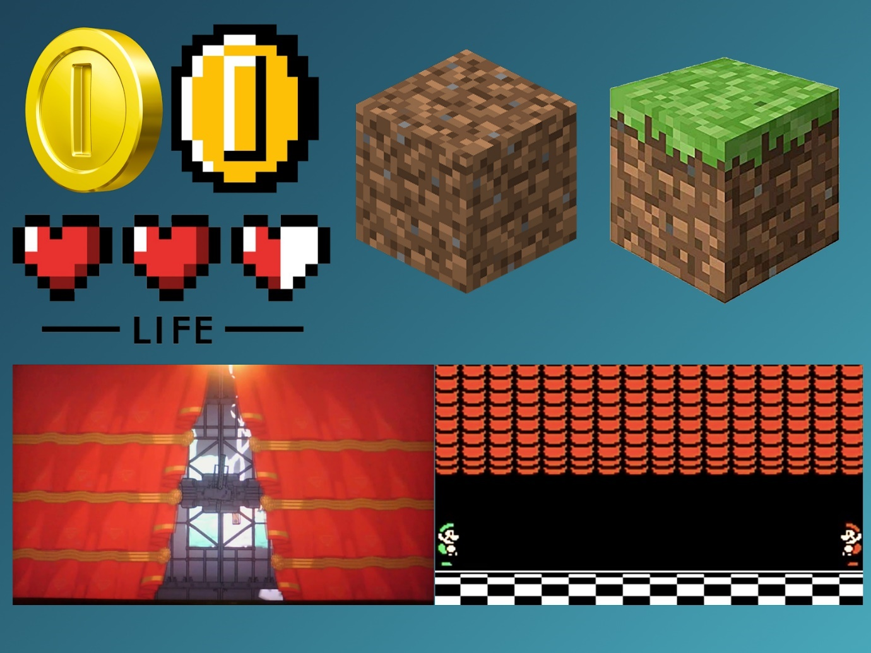

To have an idea of what I wanted my game to look like I made a mood board. In the game, I will base the design of my coins off of the ones used throughout the Mario series. For the health bar of my character as reference, I put up a picture of the classic hearts from the Zelda series. For the terrain of my game, I looked at the infamous game Minecraft for reference as that game is mostly about travelling the blocky world through the different terrains such as grass, dirt, sand, ice and stone. For the title screen of my game, I wanted curtains as to suggest that the player is part of a show and when I thought of other games that did this Battle Block theatre and Super Mario Bros 3 so I placed them onto the mood board as inspiration.

# Title Screen Idea

For the title screen of my game I wanted show curtains in the background to indirectly tell the player that they are taking part in a show. The title is then in front of the curtains with the start button making it clear for the player on how to start playing the game.

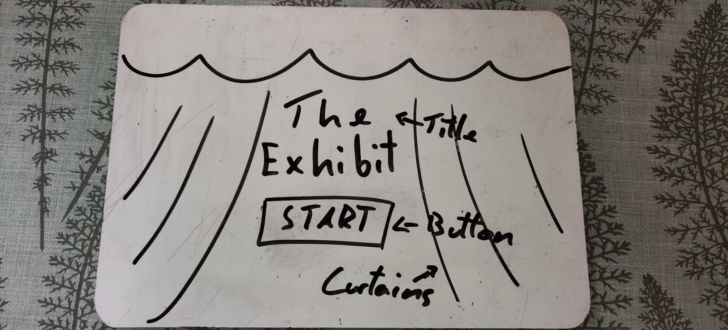

# Level 1 Screen Idea

For the HUD I have the players health and the amount of coins they have in the top left. With the level design of my game I wanted it to be simple at first with no enemies and only coins and boxes for the player to interact with and then the difficulty will increase in small increments. For the HUD of my game I wanted the information to be placed in the same position as other platformer games as to make the player feel familiar with the game layout comforting the player making them want to play more of the game.

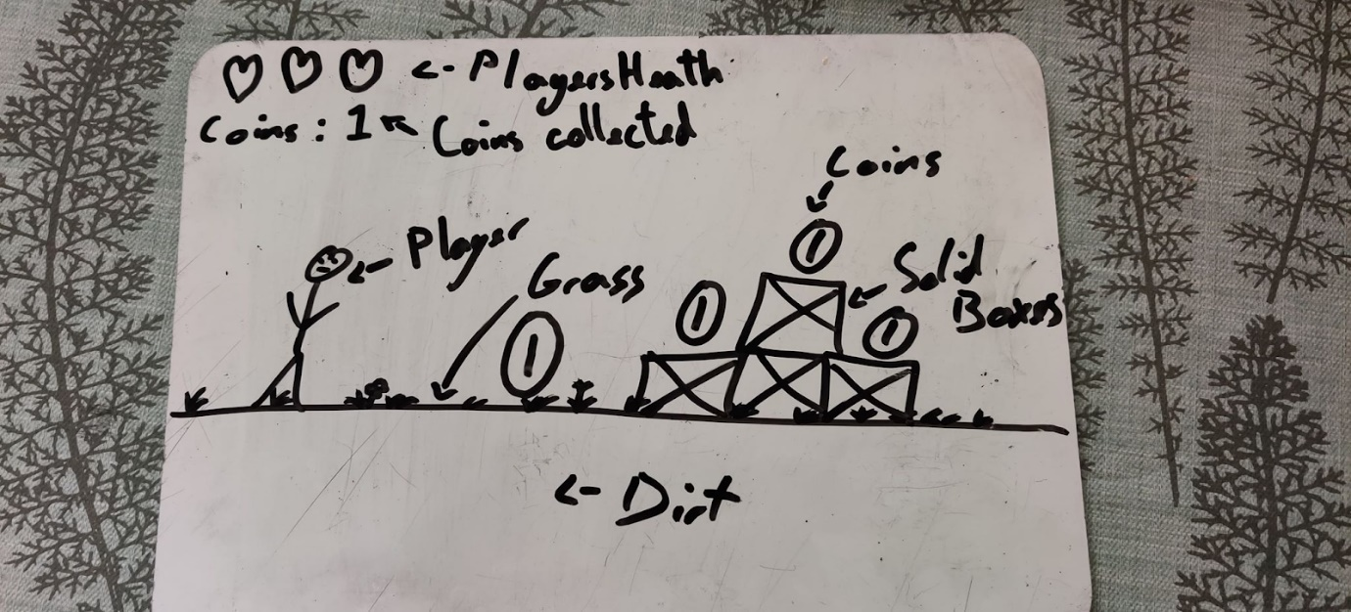

# Game Over Screen Idea

For my last screen of the game I wanted to make the background simple as to not distract the player from the text informing the player that they have lost. I wanted the familiar button used on the starting screen so that the player indirectly knows that clicking the button will take them back to level 1.

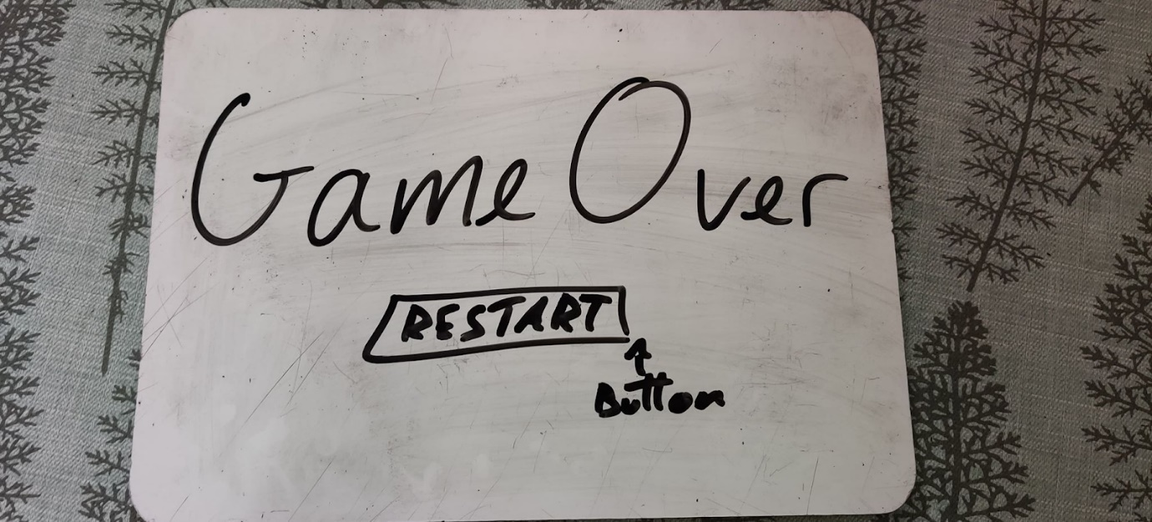

# Asset List

For the creation of my interface, I wrote down a list of art assets I will need to make. This made me more productive as I knew exactly what to create next in my project.

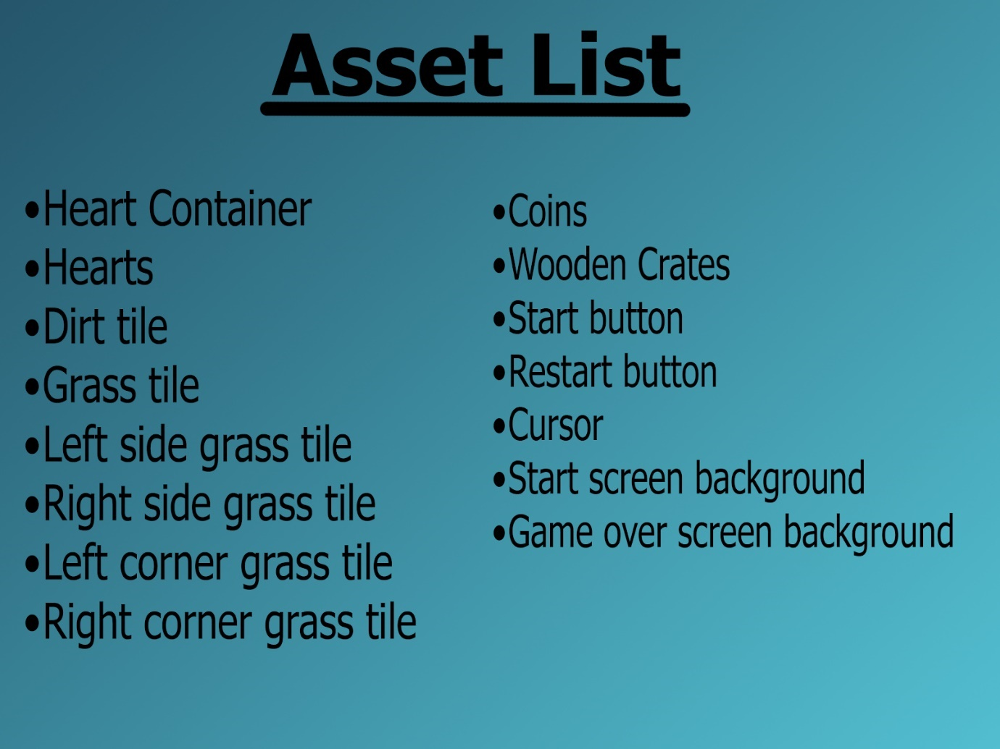

# Game Inputs and Outputs

## Input Details

|  |  |  |
| --- | --- | --- |
|  | Input Action Description | Method of Input |
| 1 | Player walks forward | Keyboard key “D” |
| 2 | Player walks backward | Keyboard key “A” |
| 3 | Player jumps | Keyboard key “W” |

## Feedback Details

|  |  |  |
| --- | --- | --- |
|  | Output Action Description | Method of Output |
| 1 | When the character jumps a jump, sound is produced | Sound effect, I added this because it immersed the player |
| 2 | When the character picks up a coin a sound effect is produced | Sound effect, I added this sound because it rewards the player with a satisfying sound for picking up a coin. |
| 3 | When the player hovers the cursor over a button it enlarges | Image enlarge, I added this because it entices the player to click the button |
| 4 | When the player dies they lose a life | Image animation, this makes the player not want to die |
| 5 | When the player picks up a coin +1 is added to the score | Score update, this intrigues the player to pick up more coins |
| 6 | When the player moves the enemy does too | Character animation, this will make the player nervous as the enemy keeps moving |

# Process Flow Diagram

For the flow chart I started off by drawing it on a whiteboard but I kept running out of space and the flowchart got to convoluted to organise on paper. To solve this, I used a free program called Draw.io on the internet, this really helped me as it made the flow chart more organised and clearer in my head so that I could keep working on it making me more productive.

## Whiteboard Flow Diagram

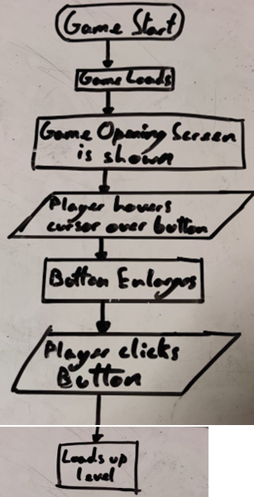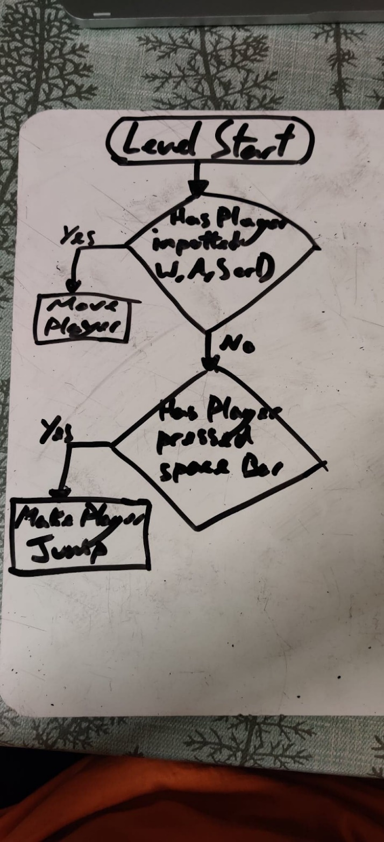

## Final Flow Diagram

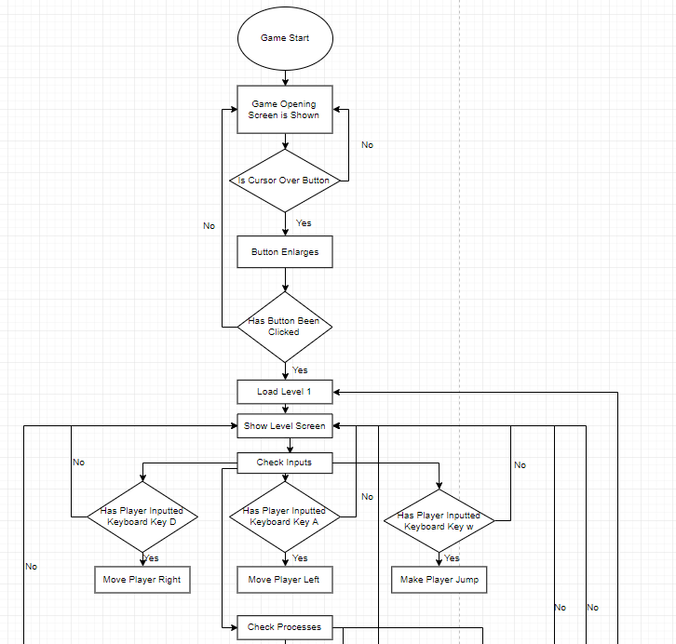

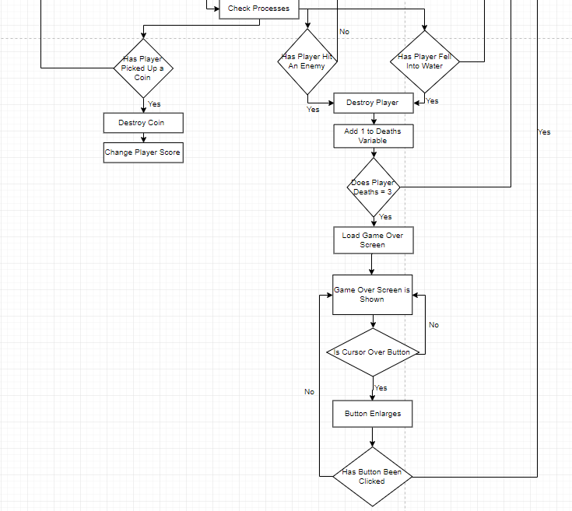

# Test Log

|  |  |  |  |  |  |
| --- | --- | --- | --- | --- | --- |
| Test Reference | Test to Be Carried Out | Expected Result | Actual Result | Action Required | Screenshot |
| 1 | Test if player moves right | Player moves right | Player moves right | Keyboard press “D” |  |
| 2 | Test if player moves left | Player moves left | Player moves left | Keyboard press “A” |  |
| 3 | Test if player jumps | Player jumps | Player jumps | Keyboard press “W” |  |
| 4 | Test if hearts deplete when player dies | Hearts will deplete | Hearts depleted | Player death |  |
| 5 | Test if opening screen button takes player to Level 1 | Player will go to level 1 | The player was taken to level 1 | Button click |  |
| 6 | Test to see if when the player dies 3 times the game over screen will load | Game over screen will load | Game over screen loaded up | Have the player die 3 times |  |
| 7 | Test if game over screen button takes player to Level 1 | Player will go to level 1 | The player was taken to level 1 | Button click |  |

# Client Requirements Analysis

|  |  |
| --- | --- |
| **The Exhibit** | |
| **Aspect:** | **Implemented: (Y/N)** |
| **Functional Game for use on pc** | **Y** |
| **Game functions via keyboard and mouse** | **Y** |
| **Videos** | **Y** |
| **Interface designs annotated** | **Y** |
| **HCI techniques used documented** | **Y** |
| **Art assets created** | **Y** |
| **Flow Diagram completed** | **Y** |
| **Mood board completed** | **Y** |
| **Game Idea** | **Y** |
| **Game Complete** | **Y** |

# Programs Used

I will be using a game engine named Construct 2 to make my game interface as it is a program that offers a wide range of functions that can be used to make good interfaces. The program is also intuitive, easy to use and has a lot of video tutorials on the internet on how to use the interface. I have used the engine in the past as well for previous assignments so I am used to the pay-out of the program making my workflow more productive.

I want to use pixel art for my game interface as I personally like how it looks. To make the pixel art assets I will use a program called Aseprite as it is free to the public if you install an older version and easy to use with its familiar interface when compared to other drawing software.

# Assets Created

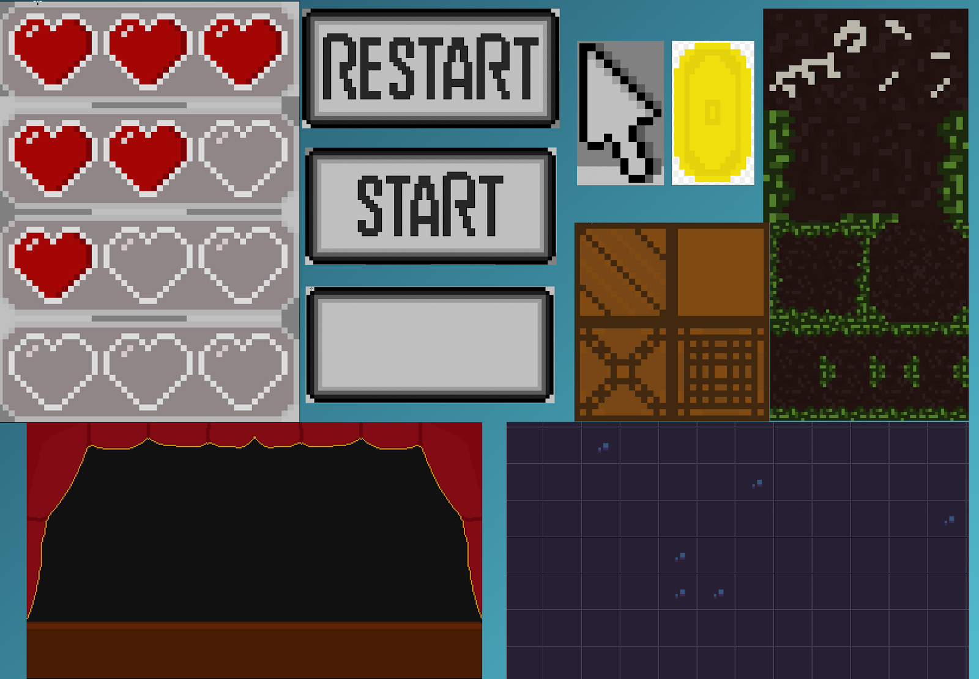

# Final Interface

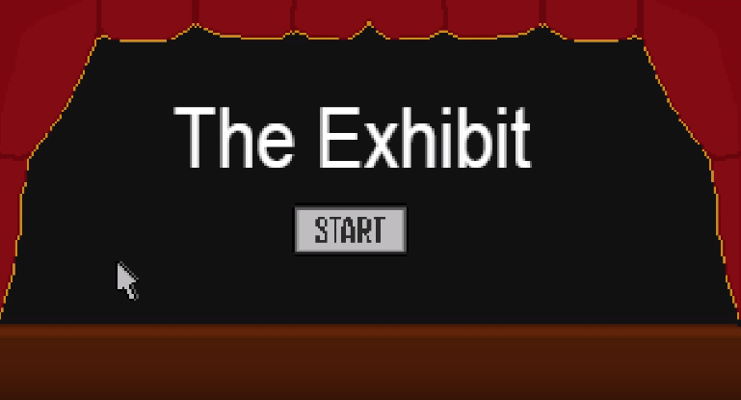

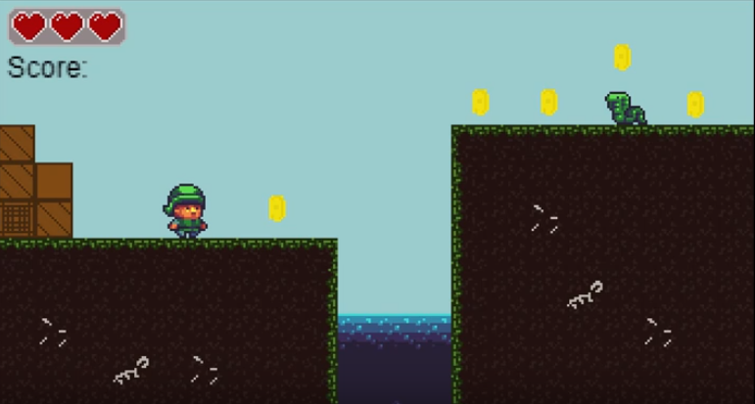 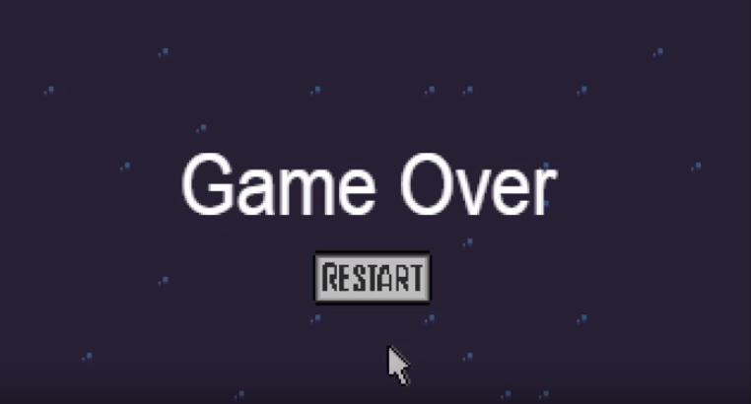

# What Else I Have Done

## Flow Chart

To access the flowchart for easier view got to:

<https://www.draw.io/>

Then open this file on the website:

# 

## Game

To access my game, you will have to open up the file in the “Game” folder within my submission in a program called Construct 2.

## Videos

I have made 3 videos which will be in my full submission of this assignment. The first video shows my art assets and the program I used to make them. The second video demonstrates my game and the final video goes through how I made the game interface using Construct 2.

# Conclusion

Overall, I feel like I have made a good and intuitive game interface that the player can understand almost autonomously. I have used various different program functions in Construct 2 to make my interface, that I had to learn to improve my game interface. From the start of my project I had a distinct idea of how I wanted my interface to look, it was then about refining that idea into something creatable in the time I had and the knowledge I have from other projects. If I were to redo this project I would change little although I would have started making my flowchart online rather than a whiteboard as it is easier to understand when using Draw.io with its minimal and clear interface design.